**STEPS TO RUN**

**STEP 1**

Start the zookeeper server

**STEP 2**

Start the Kafka server

**STEP 3**

START THE MAIN MICROSERVICE 🡪 MainControlService

Port 🡪 8083

**STEP 4**

START THE SERVICE 1 🡪 kafka-producer [ignore filename, it is a micro service]

This is both a consumer and producer so it is service 1

Port 🡪 8081

**STEP 5**

START THE SERVICE 2 🡪 kafka-consumer [ignore filename, it is a micro service]

This is both a consumer and producer so it is service 2

Port 🡪 8082

**STEP 6**

**To publish a message from service 1**

[http://localhost:8083/start/publish1/{msg}](http://localhost:8083/start/publish1/%7bmsg%7d)

Eg

<http://localhost:8083/start/publish1/hello>

Hello 🡪 message

Service1 uses topic1 to send messages

And listens to topic2

From service 2 as a consumer in console

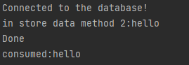

**To publish a message from service 2**

[http://localhost:8083/start/publish2/{msg}](http://localhost:8083/start/publish2/%7bmsg%7d)

Eg

<http://localhost:8083/start/publish2/hi>

Hi 🡪 message

Service2 uses topic2 to send messages

And listens to topic1

From Service 1 as a consumer

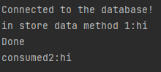

**DB used PostgreSQL**

One table for each service

**Table 1**

Table name: Service1, column name: data

**Table 2**

Table name: Service2, column name: data